**SET CHEETSHEEET.**

**What is Set in python?**

A Set is an unordered collection data type that is has no duplicate elements.

Examples of Sets

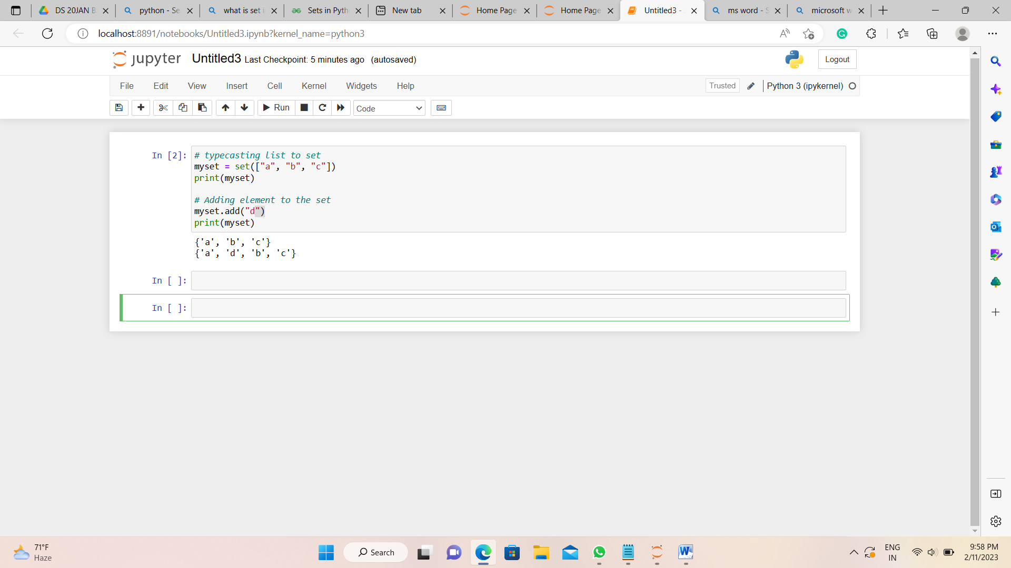

## Duplicate Items in a Set

Let's see what will happen if we try to include duplicate items in a set.

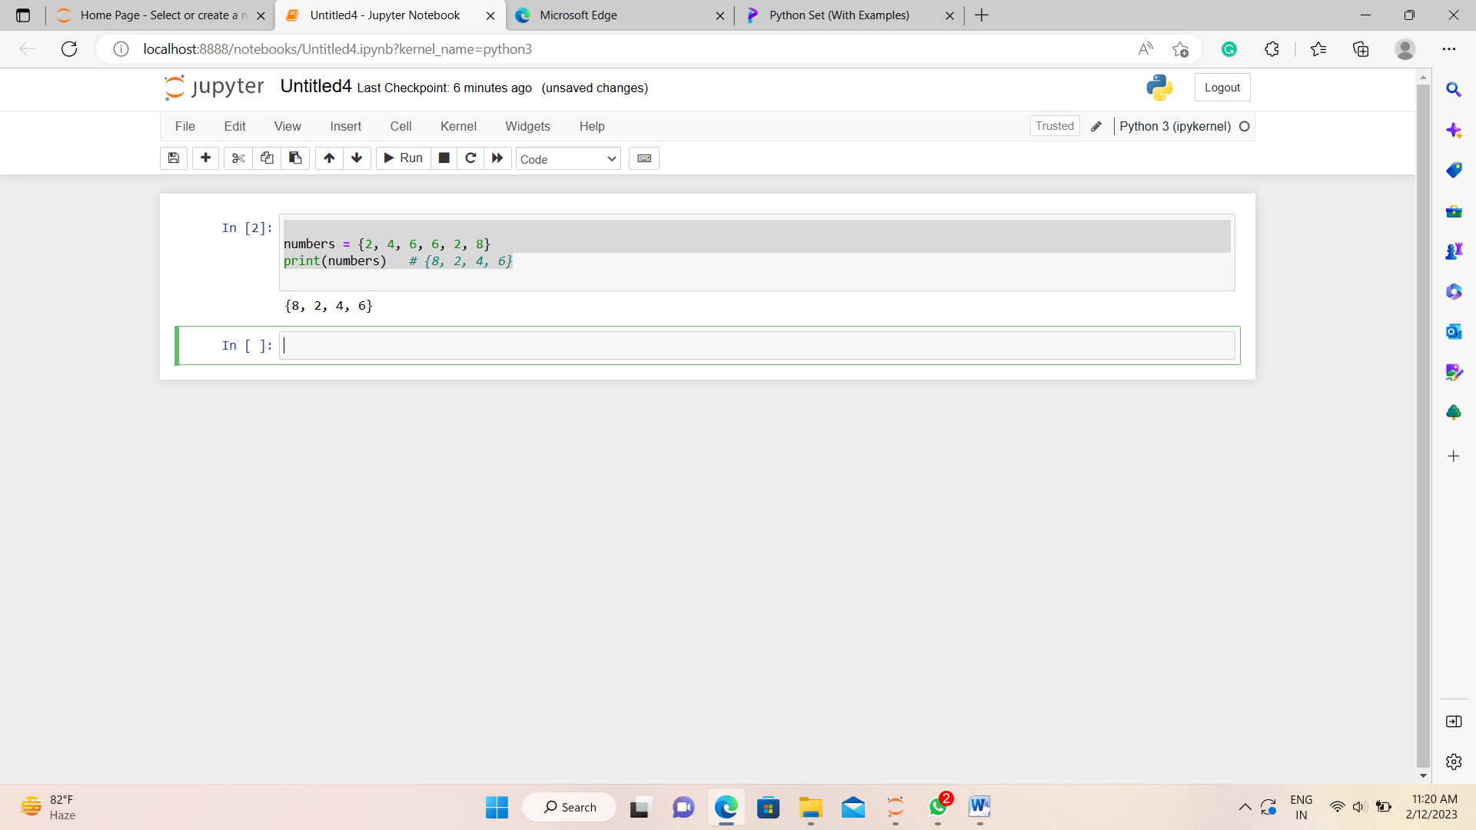

## Create a Set in Python.

A set can have any number of items and they may be of different types integer, float, tuple, string etc...

Let's see an example,

## 

# create a set of string type

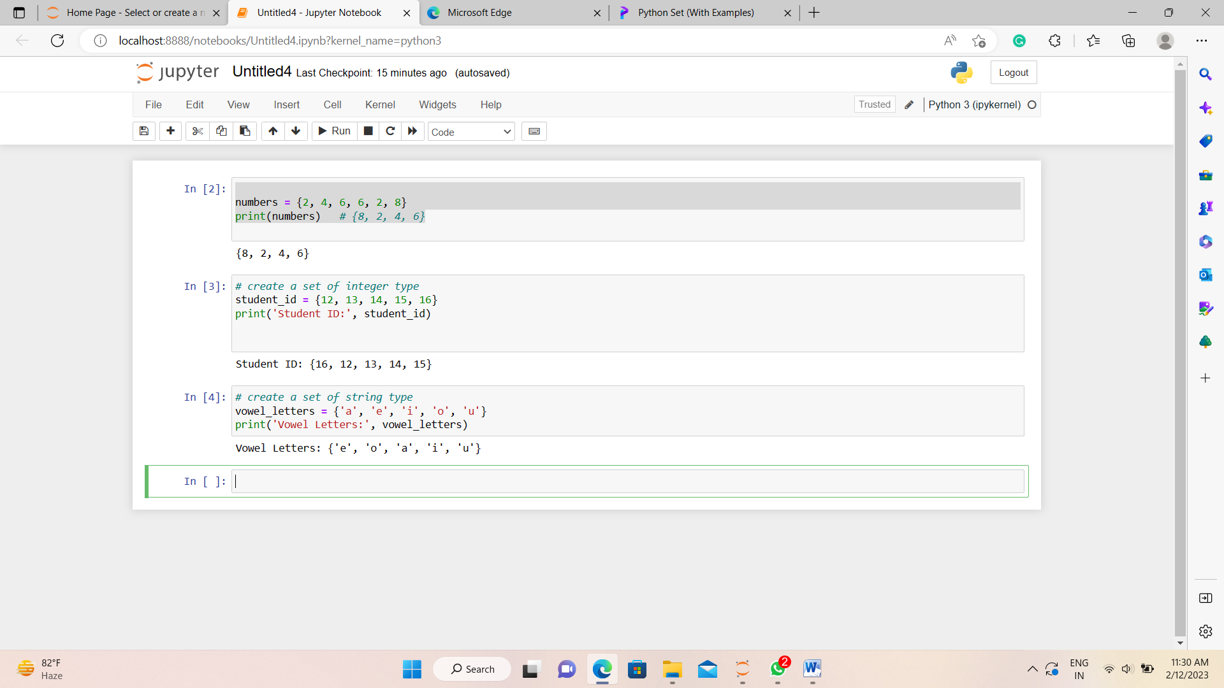

# create a set of mixed data types

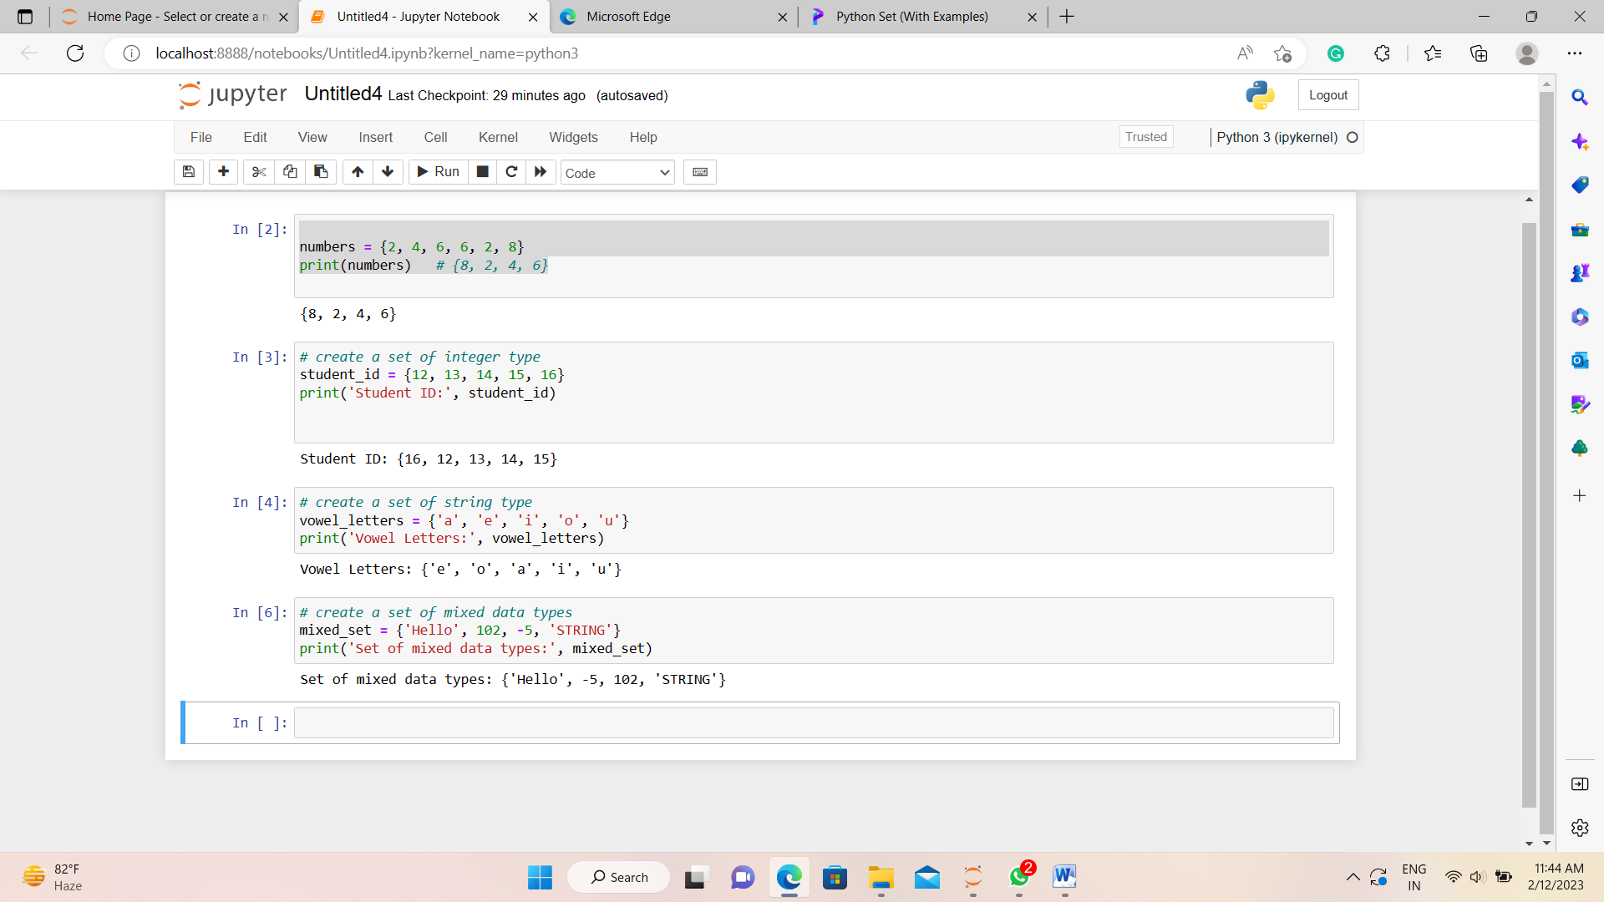

## Create an Empty Set in Python

Creating an empty set is a some different. Empty curly braces {} will make an empty dictionary in Python.

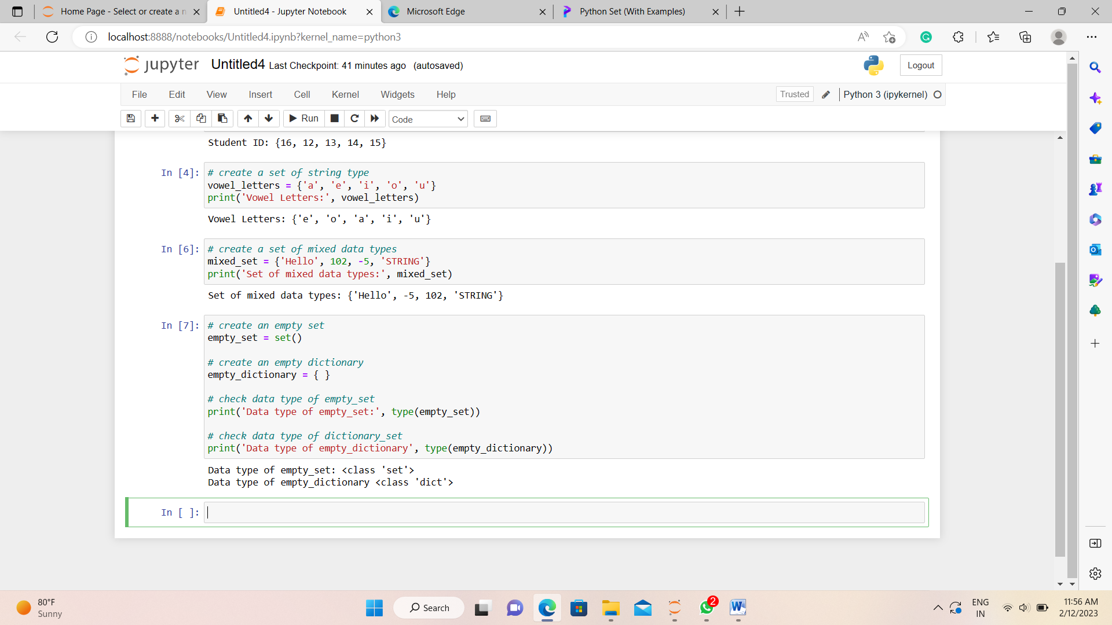

### Add Items to a Set in Python.

In Python, we use the add() method to add an item to a set.

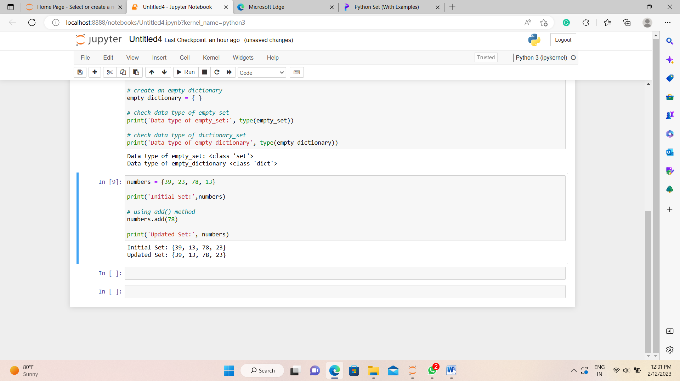

## Remove an Element from a Set.

We use the discard() method to remove the specified element from a set.

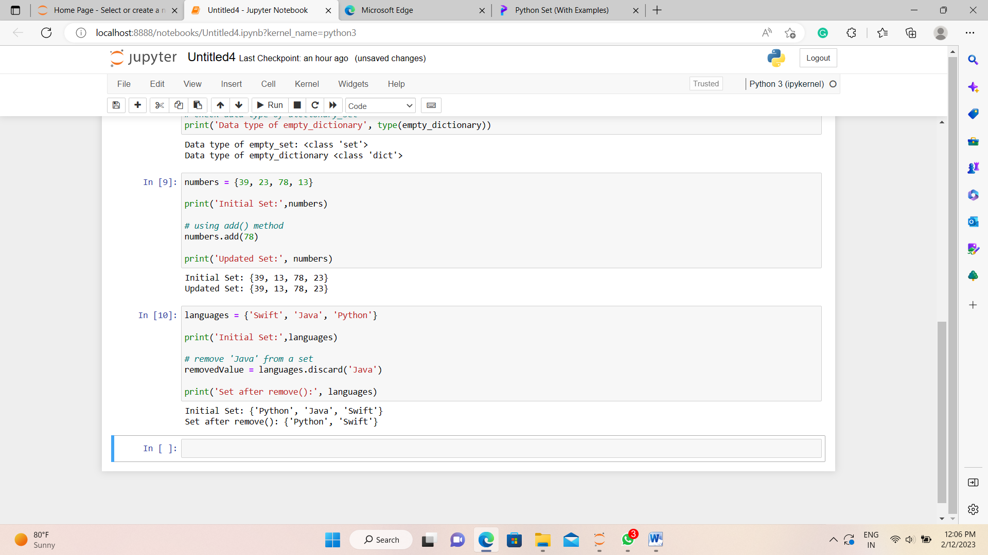

|  |  |
| --- | --- |
| Function | Description |
| [all()](https://www.programiz.com/python-programming/methods/built-in/all) | Returns True if all elements of the set are true (or if the set is empty). |
| [any()](https://www.programiz.com/python-programming/methods/built-in/any) | Returns True if any element of the set is true. If the set is empty, returns False. |
| [enumerate()](https://www.programiz.com/python-programming/methods/built-in/enumerate) | Returns an enumerate object. It contains the index and value for all the items of the set as a pair. |
| [len()](https://www.programiz.com/python-programming/methods/built-in/len) | Returns the length (the number of items) in the set. |
| [max()](https://www.programiz.com/python-programming/methods/built-in/max) | Returns the largest item in the set. |
| [min()](https://www.programiz.com/python-programming/methods/built-in/min) | Returns the smallest item in the set. |
| [sorted()](https://www.programiz.com/python-programming/methods/built-in/sorted) | Returns a new sorted list from elements in the set(does not sort the set itself). |
| [sum()](https://www.programiz.com/python-programming/methods/built-in/sum) | Returns the sum of all elements in the set. |

## Iterate Over a Set in Python.

## 

## Find Number of Set Elements.

## 

## Python Set Operations.

## Python Set provides different built-in methods to perform mathematical set operations like union, intersection, subtraction, and symmetric difference.

### Union of Two Sets

The union of two sets **A** and **B** include all the elements of set **A** and **B**.

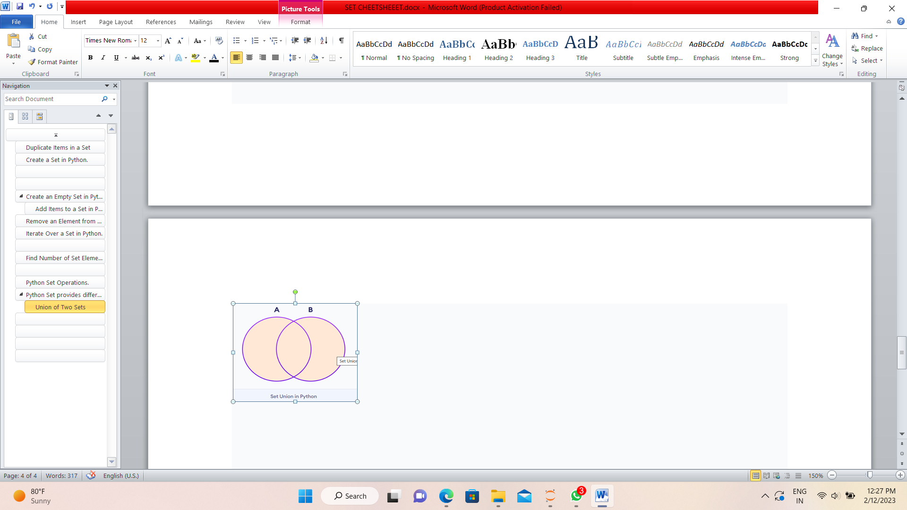

We use the | operator or the union() method to perform the set union operation.

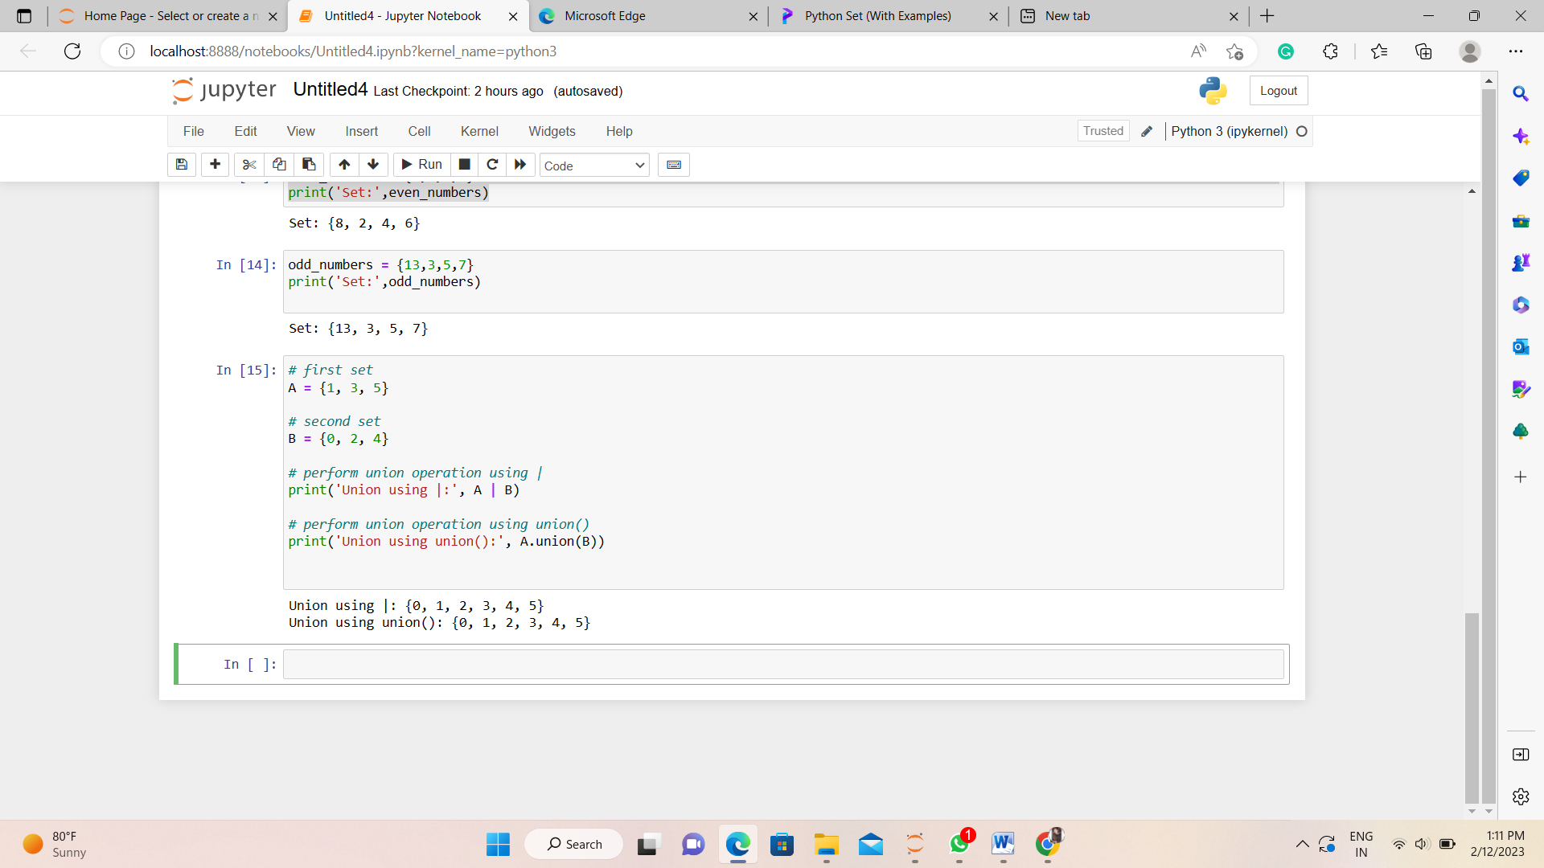

A|B and union() is equivalent to A ⋃ B set operation.

### Set Intersection

The intersection of two sets **A** and **B** include the common elements between set **A** and **B**.

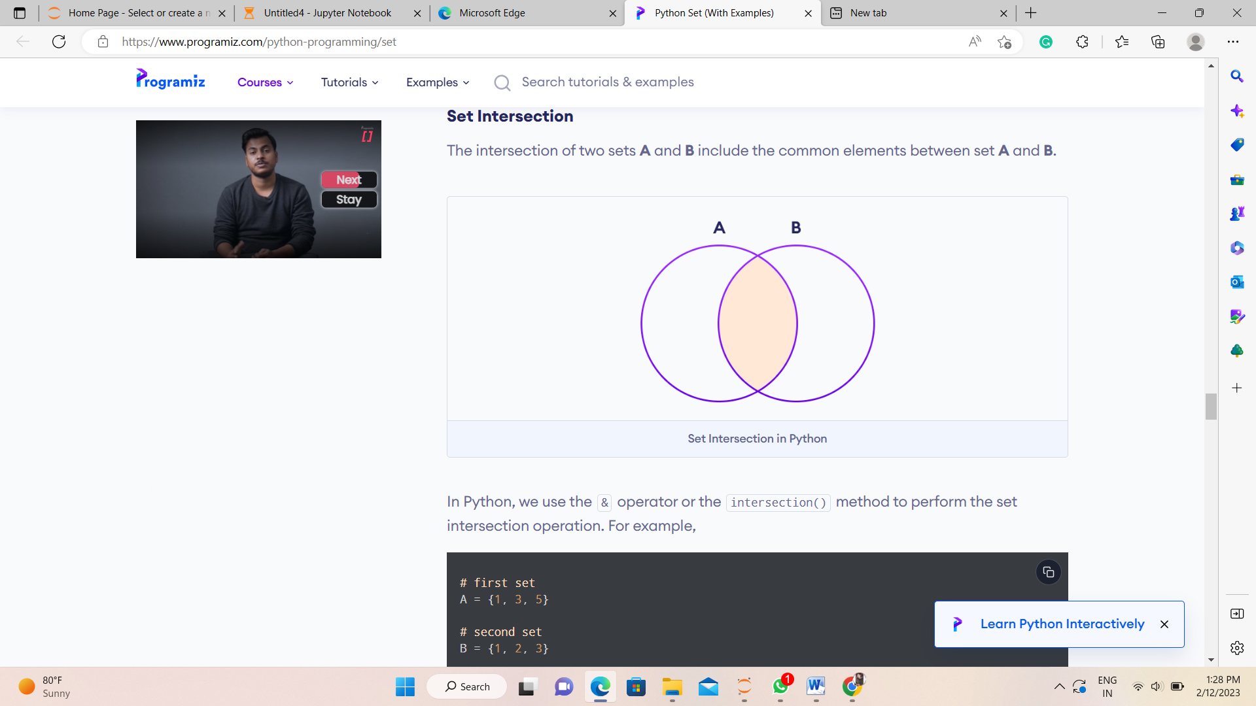

In Python, we use the & operator or the intersection() method to perform the set intersection operation.

